

**EDGE CSE CUET DIGITAL SKILLS TRAINING**

Project Report on

**“Blog Nest”**

**Batch Name: CBI-033 Python with Django**

This Project report (CBI-033 Python with Django) is submitted to the Department of CSE, Chittagong University of Engineering and Technology (CUET) to fulfil the partial requirement of the Degree of Python with Django Course.

**Submitted by:**

**Name:** Md. Rabiul Hasan Shimul

**Batch:** CBI-033 Python with Django

**Supervised by:**

Shaikat Sharma

Trainer, EDGE-CSE-CUET

October, 2024

**DECLARATION**

This project report is hereby submitted to the Department of Computer Science & Engineering, Chittagong University of Engineering and Technology (CUET), for partial fulfilment of the requirements toward the degree of Python with Django. Thus, we hereby declare that this report has been prepared based on the surveys we found and my original work, which has not been submitted anywhere for any award. Works found by other researchers are referred to with due reference. All the contents provided here are based on our efforts dedicated to the completion of the project. The work is done under the guidance of Mr. Shaikat Sharma, Trainer at the EDGE-CSE-CUET program.

______________________________

Name: Md. Rabiul Hasan Shimul

Batch: CBI-033 Python with Django

:

**ACKNOWLEDGEMENT**

It is our privilege to express our sincerest regards to our project Supervisor, Mr Shaikat Sharma, for his valuable input, guidance, encouragement, whole-hearted cooperation and constructive criticism throughout our project. His useful suggestions for this whole work and cooperative behaviour are sincerely acknowledged. We deeply express our sincere thanks to him for encouraging and allowing us to present the project on the topic “Blog Nest” at our department premises for the partial fulfilment of the requirements. We take this opportunity to thank all our trainers who have directly or indirectly helped with our project. We pay our respects and love to our parents and all other family members and friends for their love and encouragement throughout our careers. Finally, we express our thanks to our friends for their cooperation and support.

______________________________

Name: Md. Rabiul Hasan Shimul

Batch: CBI-033 Python with Django

**ABSTRACT**

**This project focuses on developing a dynamic blog application using Django, aimed at providing a responsive and visually engaging user experience. Key features include a card-based layout for posts, advanced search functionality, and efficient content management via the Django admin panel. The application is designed for optimal performance across devices, utilizing Bootstrap or custom CSS for a consistent look.**

**Django handles the back-end operations like database management and user authentication. Challenges like optimizing database queries and ensuring scalability were addressed by using Django’s Object-Relational Mapping (ORM) and adhering to development best practices.**

**The project documents the development lifecycle, resulting in a functional blog platform with potential for future enhancements such as user registration, commenting, social media sharing, and analytics. Overall, it showcases Django’s effectiveness in building scalable, feature-rich web applications.**

**Advantages**

1. **Ease of Use**: Blog Nest offers intuitive tools and customizable templates, making it simple for users to create and manage their blogs without needing advanced technical skills.
2. **Interactive Community**: Users can engage with each other through comments, likes, and follows, fostering a sense of community and encouraging interaction.
3. **Diverse Content**: With a wide range of categories and topics, Blog Nest caters to various interests, ensuring that readers can always find something new and engaging.
4. **SEO Benefits**: Blog Nest is designed to be SEO-friendly, helping blogs rank higher in search engine results and attract more organic traffic.
5. **Supportive Environment**: The platform provides a supportive community for writers, offering feedback and encouragement to help them grow and improve their blogging skills.

**INTRODUCTION**

This project aims to build a simple yet functional blogging application using Django, focusing on greater control and scalability compared to traditional CMS like WordPress. Django's robust security features and the Model-Template-View (MTV) architectural pattern make it an ideal choice for web applications.

**Key features include:**

* **Visually Appealing and Responsive User Interface:** Ensures an attractive and user-friendly experience on all devices.
* **Dynamic Blog Post Display:** Highlights essential elements like titles, snippets, authors, and publication dates for easy browsing.
* **Search Functionality:** Allows users to filter posts by keywords for rapid content discovery.

These features create a solid foundation for future enhancements, ensuring the platform remains user-friendly and adaptable for growth.

**METHODOLOGY**

**Planning and Requirements:**

Prior to development, a comprehensive set of requirements was established to guide the blog platform's creation, categorized into functional and non-functional requirements.

**Functional Requirements:**

* **Dynamic Blog Post Display:** The platform must dynamically present blog posts from the database for easy access to the latest content.
* **Search Functionality:** An integrated search bar must allow users to filter blog posts based on keywords in titles or content for quick information access.
* **Card-Based Layout:** The interface should display blog posts in an appealing card format, including essential information such as title, author, publication date, and a content snippet for a brief overview.

**Non-functional Requirements:**

* **Responsiveness:** The website should ensure compatibility and optimal viewing on all devices, including mobile, tablet, and desktop.
* **Usability and Aesthetics:** The platform should be visually attractive, featuring a clean layout that enhances user navigation and engagement.
* **Performance:** The blog application should load quickly and efficiently manage multiple entries, ensuring a smooth user experience even with a large volume of content.

**Development Process:**

1. **Setting Up the Project:** Development began by creating a virtual environment to manage project dependencies. Django was then installed, and the project, along with its necessary apps, was initialized. SQLite was selected as the database for its simplicity and seamless integration.
2. **Creating Data Models:** The core data model for the blog platform is encapsulated in the BlogPost model, including essential attributes like title, author, content, and creation timestamp. Future enhancements could add features like tagging, categories, and user comments for improved content organization.
3. **Templates and Views:** Django’s templating engine was utilized to separate design from application logic. Views were developed to fetch data from the database and pass it to corresponding templates for display. HTML templates styled with Bootstrap ensured responsiveness. A critical view is the homepage view, responsible for fetching and displaying all blog posts.
4. **Front-End Design:** The design emphasized a card-based layout for presenting blog posts. Cards serve as visual containers that organize content snippets in a digestible format, allowing users a quick overview of multiple posts. Each card typically includes:

* An optional featured image
* The blog title
* A brief description or snippet from the blog post
* The author’s name and publication date

1. **Search Functionality:** A basic search function was implemented to enable users to search blog posts by title or content. The search query is matched against blog titles and snippets, with results displayed in the same card-based format as the main posts, significantly enhancing user experience by simplifying content access.
2. **Responsive Design:** Ensuring full responsiveness required extensive testing on various devices. The responsive design adjusts to the device’s screen size, whether a mobile phone, tablet, or desktop computer. Implementing Bootstrap’s grid system and media queries facilitated appropriate resizing and repositioning of elements, ensuring optimal user experience across all devices.

Following this methodology ensured that the blog application met both functional and non-functional requirements while providing a solid foundation for future enhancements and scalability.

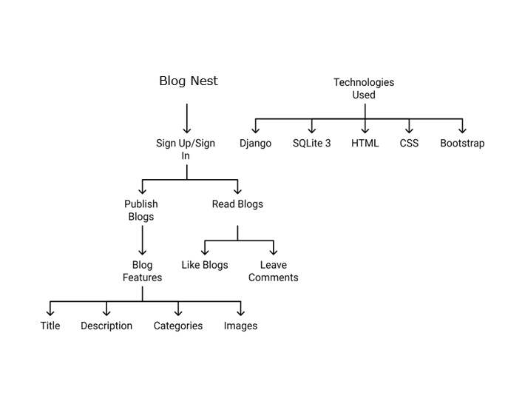

Figure No: 01

**RESULTS**

The project results in a fully functional blog platform characterized by a modern, visually appealing interface. It effectively displays blog posts using a card-based layout, and the integrated search functionality allows users to efficiently filter content based on specific keywords.

Design Outcome

The card-based design presents blog posts intuitively and attractively. Each card is thoughtfully constructed to include essential information such as the title, author, and content preview, enabling users to quickly identify posts of interest. Incorporating high-quality images further enhances the visual appeal and engagement, making the content more inviting.

Performance Testing

• Device Compatibility: The platform underwent rigorous testing on various devices, including mobile phones, tablets, and desktops. Results showed that the design-maintained integrity and responsiveness across all screen sizes, ensuring a seamless user experience.

• Content Handling: The platform was evaluated for its ability to efficiently manage multiple blog posts. Testing confirmed robust performance even with a significant volume of content, allowing for smooth navigation and quick loading times.

Search Feature

The search functionality allows users to quickly find blog posts by entering relevant keywords. During testing, this feature performed excellently, displaying filtered results almost instantly. The search capability significantly enhances overall platform usability, making it easier for users to find specific content of interest.

User Feedback

To evaluate the platform’s effectiveness, several users were invited to provide feedback on usability, design, and overall experience. Responses were overwhelmingly positive, with users highlighting:

• Clean Layout: Users appreciated the organized layout that facilitated easy navigation and content discovery.

• Ease of Navigation: The intuitive design allowed effortless navigation, contributing to a positive overall experience.

• Search Functionality: Users praised the quick content filtering through the search feature, which made locating specific posts more convenient

**CONCLUSION**

This project successfully developed a dynamic, responsive blog platform with a visually appealing and easy-to-navigate interface. Key features such as the card-based layout, efficient search functionality, and responsive design ensure a user-friendly experience across all devices.

However, the development process presented challenges, particularly in maintaining design responsiveness while ensuring functionality. Balancing aesthetic appeal with performance and usability was paramount.

Future improvements may include:

• User Registration and Authentication: Implementing user accounts would facilitate personalized experiences and interactions, allowing for comments and post submissions.

• Enhanced Search Capabilities: Expanding the search feature to include advanced filtering options, such as categories and tags, could improve content discovery.

• Commenting System: Enabling comments on blog posts could foster user engagement and interaction.

Overall, this project underscores the potential of Django as a powerful tool for creating scalable web applications, offering significant flexibility and efficiency in blog development. The resulting platform effectively meets user needs and stands ready for future enhancements, positioning it as a valuable resource for content creators and consumers alike.

**References**

1. **Django Documentation. (n.d.).** Comprehensive documentation for the Django web framework, detailing its features, installation, and usage. Retrieved from <https://docs.djangoproject.com/en/stable/>
2. **Python Software Foundation. (n.d.).** Official Python documentation that provides a thorough overview of Python, including installation, language syntax, and standard library modules. Retrieved from <https://www.python.org/doc/>
3. **Microsoft Visual Basic Documentation.** (n.d.). Documentation for Visual Basic, offering resources on programming concepts, language features, and practical examples for developers. Retrieved from <https://docs.microsoft.com/en-us/dotnet/visual-basic/>
4. **Bootstrap Documentation. (n.d.).** A guide to using Bootstrap, a popular front-end framework for developing responsive and mobile-first websites. Retrieved from <https://getbootstrap.com/docs/5.3/getting-started/introduction/>
5. **W3Schools. (n.d.).** A tutorial on creating responsive websites, covering key principles and techniques for making web content adaptable to various screen sizes. Retrieved from <https://www.w3schools.com/howto/howto_make_a_website_responsive.asp.>